Lesson Notes for Using Large Language Models (LLMs) with FHIR – Concepts, Use Cases & Foundations (Lesson 17)

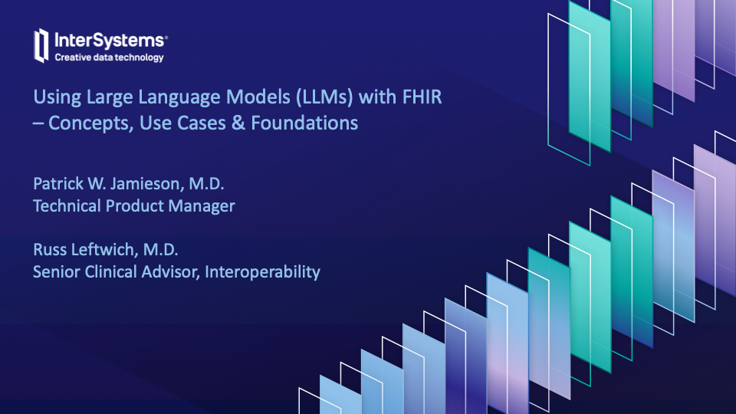

Show only a few seconds
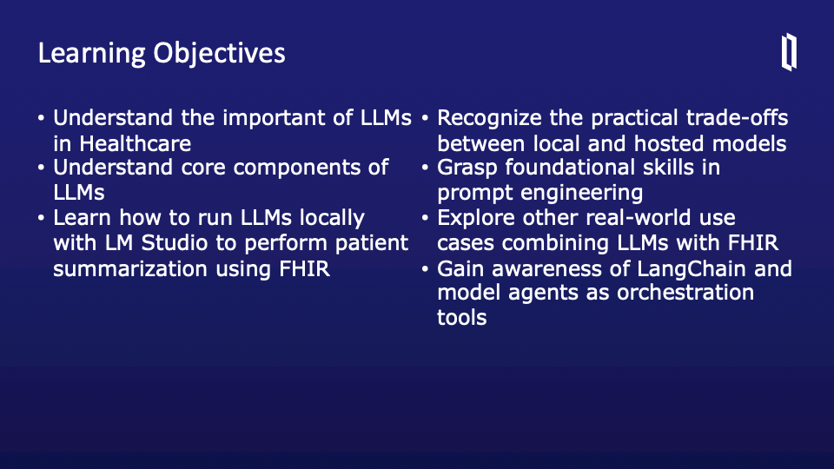

Welcome to this lesson on using Large Language Models with FHIR. Let's begin by reviewing our learning objectives.

First, we’ll build a foundational understanding of why LLMs are increasingly important in healthcare. From summarizing patient records to generating insights, LLMs offer powerful ways to work with clinical data.

We'll also break down the core components that make LLMs function, including attention mechanisms and token embeddings, giving you the background to understand how these models interpret and generate text.

Then, we’ll explore running LLMs locally using LM Studio. This is especially valuable for healthcare environments where data privacy and compliance are critical. We'll use a hands-on example that performs patient summarization directly on FHIR data.

We'll compare the trade-offs between running models locally and using hosted APIs—touching on speed, cost, privacy, and accessibility.

Next, we’ll discuss prompt engineering, a crucial skill for shaping model output and improving relevance in healthcare tasks.

We’ll also look at real-world applications where LLMs have been used with FHIR—like clinical decision support or cohort analysis.

These objectives set the stage for both practical skills and conceptual clarity as we move through the session.

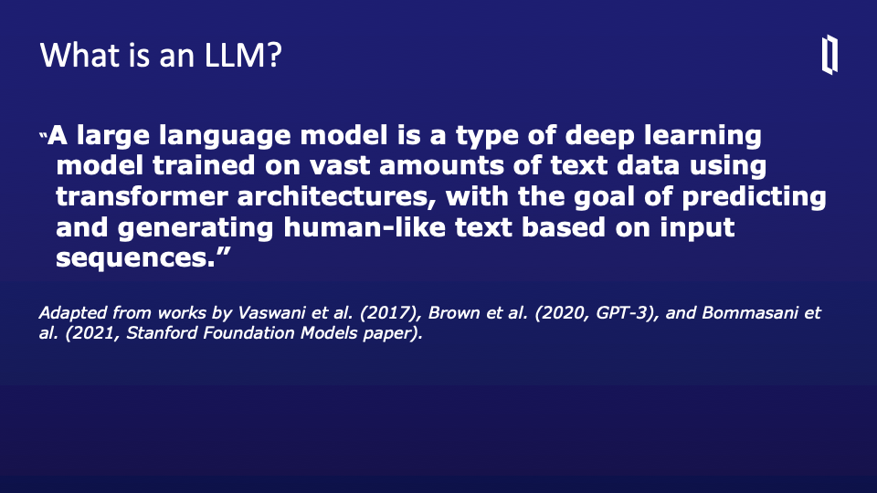

Before diving deeper into how LLMs work with FHIR, let’s start by defining what an LLM actually is.
A large language model, or LLM, is a type of deep learning model designed to work with human language. These models are trained on massive datasets made up of text from books, websites, articles, code, and more. The goal is to learn patterns in language so well that they can generate text that feels human-like.

The core architecture that powers modern LLMs is the Transformer, introduced by Vaswani et al. in 2017. This architecture made it possible to handle much longer sequences of text efficiently and to understand relationships between words across those sequences.

During training, the model learns to predict the next word in a sentence based on the words that came before it. With enough data and computation, it learns grammar, facts, reasoning patterns—even some domain-specific knowledge.

The quote on this slide summarizes this beautifully: LLMs predict and generate human-like text based on input sequences. This predictive capability is what makes them so flexible for use in healthcare, from summarizing notes to answering clinical questions.

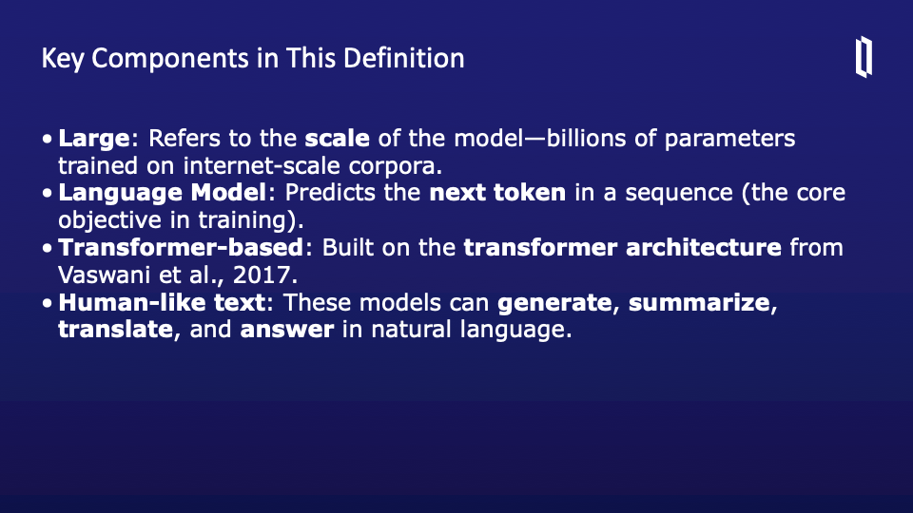
Let’s break down the key terms from the definition of an LLM.

First, “Large” refers to the massive scale of these models. We're talking billions of parameters—weights that the model learns during training. These parameters allow the model to encode incredibly complex patterns in language.

Next, “Language Model” means that the model's core function is to predict the next word—or more precisely, the next token—in a sequence. This simple idea forms the foundation of how LLMs generate coherent, contextually relevant text.

The term “Transformer-based” is essential. Transformers are the architecture that made modern LLMs possible. Introduced by Vaswani et al. in 2017, this design uses attention mechanisms to understand relationships across long sequences of text efficiently.

Finally, “Human-like text” describes the outputs these models are capable of producing. They can generate, summarize, translate, and answer questions—all in natural, readable language. This versatility is what makes them so useful in real-world healthcare applications.

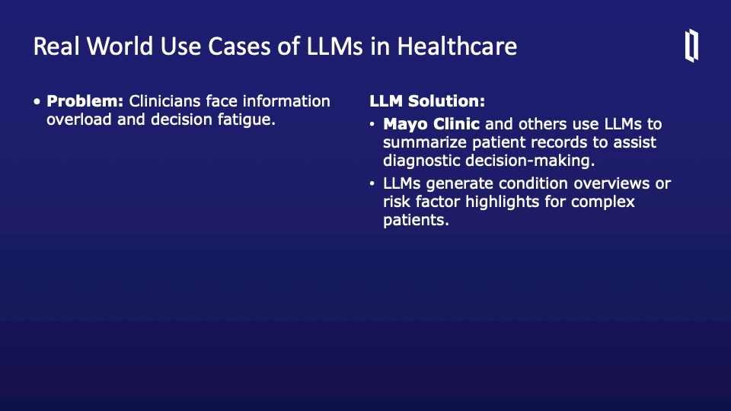
One major pain point in healthcare is cognitive overload. Clinicians must synthesize massive amounts of patient data quickly—often under time pressure. LLMs can help by generating concise patient summaries from electronic health records. At Mayo Clinic, for example, models are used to provide overviews or extract relevant risk factors for complex patients. This use of LLMs acts as a second set of eyes, surfacing key information that might otherwise be buried in notes, labs, or problem lists. The result is faster, more informed clinical decision-making and less chance of oversight in complex cases. It’s important to note that these summaries are context-aware—LLMs look at the entire record to present the most relevant insights
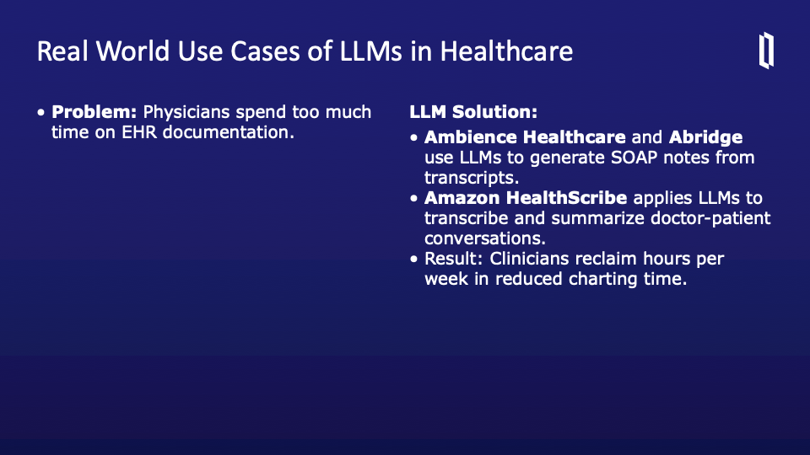
Another huge opportunity is reducing the documentation burden. Many physicians report spending hours a day writing SOAP notes or updating charts. LLM-powered tools like Ambience Healthcare and Abridge aim to change that by turning ambient transcripts into structured clinical notes. Amazon HealthScribe similarly leverages LLMs to transcribe and summarize entire doctor-patient conversations. This automation not only saves time but also reduces burnout and improves work-life balance for clinicians. By turning raw audio or free-text transcripts into accurate, structured summaries, LLMs let doctors focus more on care and less on clicks
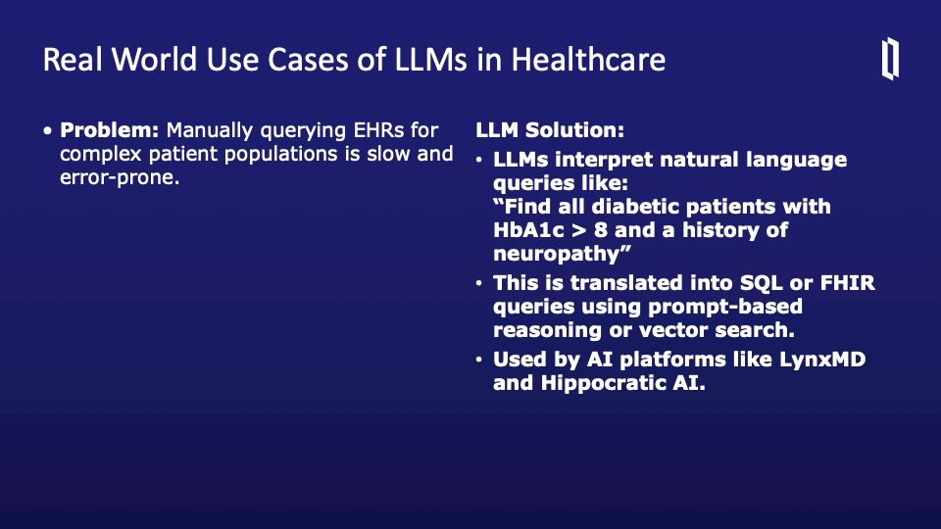

Extracting insights from EHRs can be tedious and error-prone—especially when clinicians need to identify complex patient cohorts. LLMs enable natural language querying of EHRs. For instance, a doctor can ask, “Find all diabetic patients with HbA1c > 8 and neuropathy,” and the model translates that into structured SQL or FHIR queries. AI platforms like LynxMD and Hippocratic AI are already using LLMs this way. This natural-language interface lowers the barrier to data exploration, enabling both clinicians and analysts to get answers quickly and accurately. It also supports more agile, responsive care delivery.

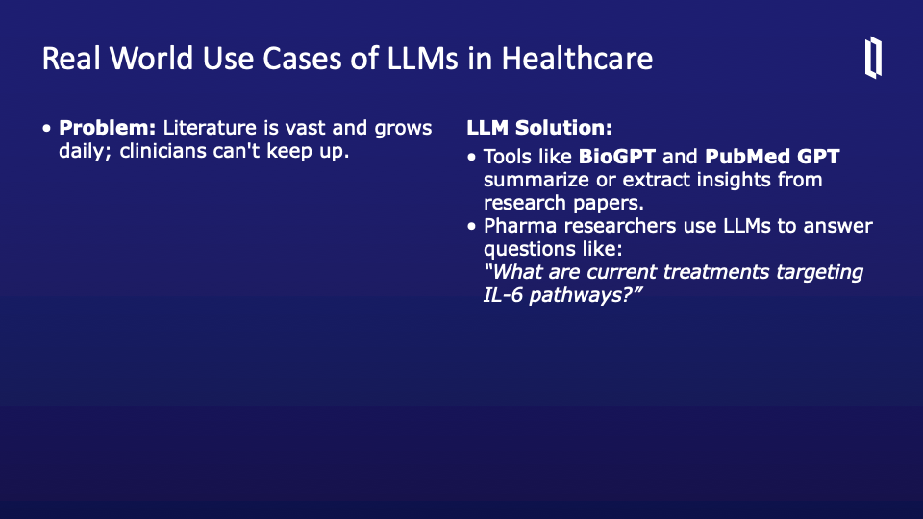
The volume of biomedical literature is overwhelming -- thousands of new papers are published daily. LLMs like BioGPT and PubMedGPT are helping researchers and clinicians extract insights more efficiently. These tools can summarize studies, answer specific queries, or find emerging trends across large corpora of research. Pharmaceutical companies also use LLMs to explore questions like, “What drugs target IL-6 pathways?” The ability to digest and synthesize scientific literature at scale is invaluable—especially for research, policy development, or evidence-based care.
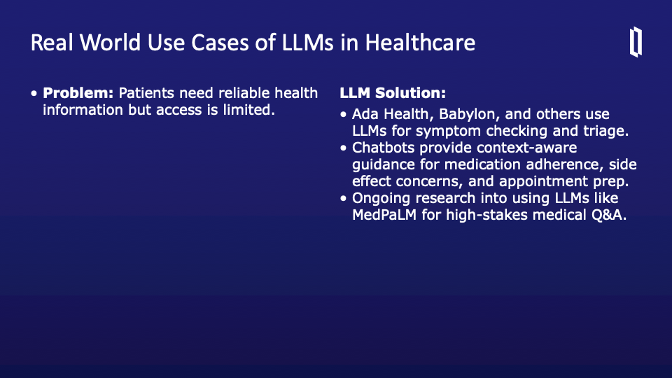
Another powerful application of LLMs is improving communication with patients. Not everyone has the same access to clinicians or the health literacy to navigate complex medical topics. LLMs are being used by companies like Ada Health and Babylon to provide intelligent symptom checkers and chatbots. These tools can guide patients through triage, explain medications and side effects, and even help prepare for appointments. The idea isn’t to replace physicians, but to supplement care between visits and make health information more accessible. At the frontier of this is MedPaLM, a model trained to answer high-stakes medical questions with clinical accuracy. It’s a promising area—but still under study for safety and reliability in real-world use
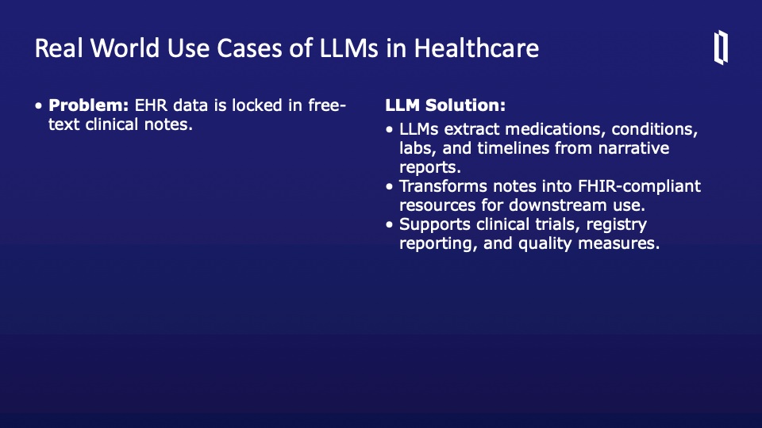
Clinical notes are a goldmine of information—but much of that value is locked in unstructured text. LLMs are being used to extract key data like medications, conditions, labs, and timelines from free-text notes. This structured data can then be transformed into FHIR resources, making it usable across systems and for various secondary uses like clinical trials, quality reporting, or population health. This process helps bridge the gap between traditional narrative documentation and modern interoperable standards. Think of it as a pipeline from doctor’s prose to computable data

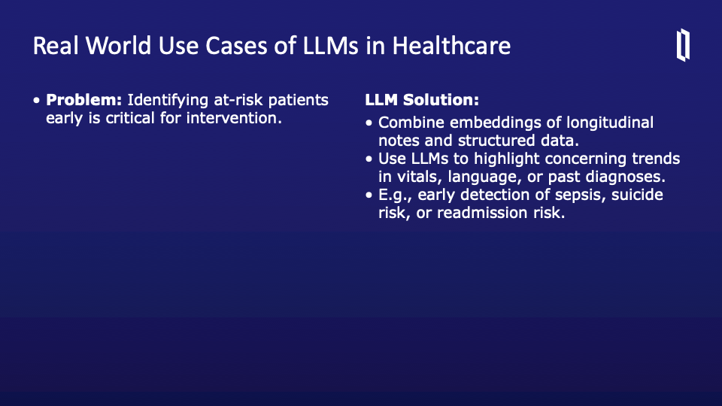
Early detection is critical in conditions like sepsis, suicide risk, or hospital readmission. LLMs can be used to analyze both structured data and longitudinal notes to identify trends or warning signs. By embedding this information and applying predictive reasoning, the model can flag subtle but concerning changes over time. This use of LLMs supports proactive, rather than reactive, healthcare—identifying at-risk patients before problems escalate. It also enhances case management by helping care teams prioritize outreach or interventions
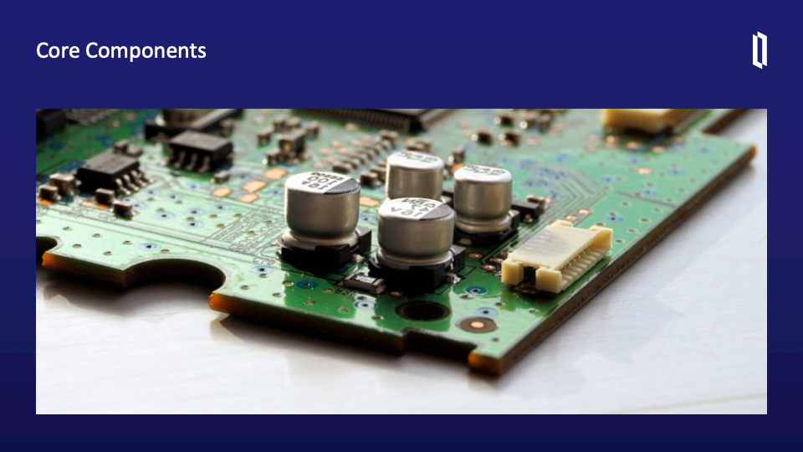

To understand how LLMs do all this, we need to explore the components that make them work. Modern LLMs didn’t appear overnight—they evolved from decades of work in natural language processing. Components like embeddings, sequence models, and transformer layers are building blocks that evolved from earlier architectures like RNNs and LSTMs. Each layer of this technology stack added greater representational power and context awareness. Over the next few slides, we’ll walk through these core ideas, starting from word embeddings and moving toward the transformer architecture that powers today’s models
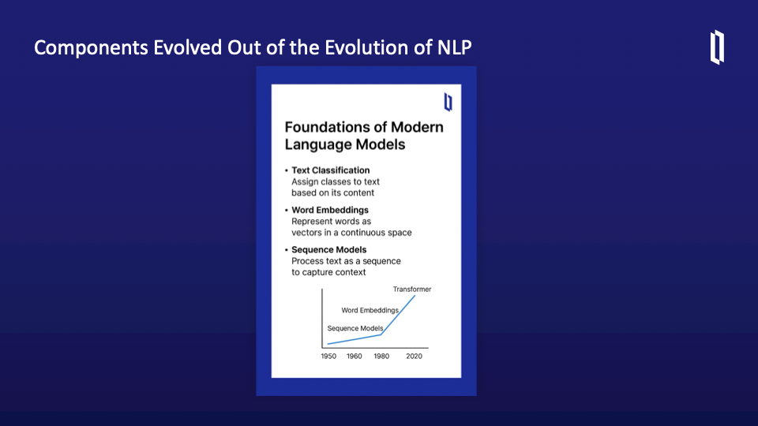
This slide offers a concise overview of how modern language models have evolved by building upon three key components in natural language processing: text classification, word embeddings, and sequence models. Let’s explore each in sequence.

We begin with text classification, one of the earliest tasks tackled in NLP. This involves assigning labels to a piece of text—whether categorizing clinical notes, detecting sentiment in patient feedback, or flagging messages for urgency. Early models did this using simple statistical methods, but it laid the groundwork for understanding how models could extract meaning from text.

Next came word embeddings. Unlike older approaches where each word was treated as a one-hot vector with no semantic meaning, embeddings represent words in a dense vector space. These vectors encode relationships—so words like “insulin,” “glucose,” and “diabetes” naturally cluster together. This innovation helped models better understand context and similarity.

Then we move to sequence models, which treat text as ordered input, capturing meaning based on the position of words. This was crucial for understanding phrases like “the patient took the medication” versus “the medication took the patient.” These models—such as RNNs and LSTMs—were a huge leap forward.

Finally, as shown in the graph, we arrive at transformers, which revolutionized NLP by combining attention mechanisms with parallel processing. Each of these components builds on the last, enabling the rich capabilities of today’s LLMs.
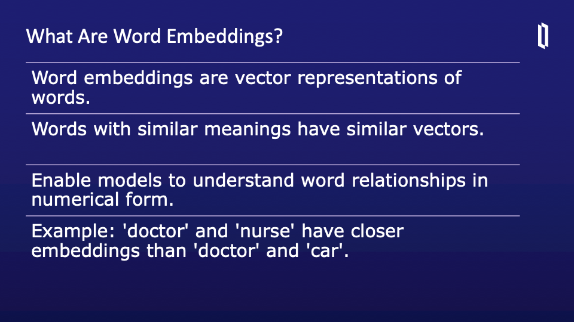

Word embeddings are one of the foundational breakthroughs in NLP. Instead of treating words as discrete symbols, embeddings represent them as vectors in a multi-dimensional space. These vectors capture semantic relationships—so words like "glucose," "insulin," and "diabetes" end up close together in that space. One popular approach is Word2Vec, which uses a skip-gram model to predict context words from a given input. This process trains the model to understand which words commonly occur together. Embeddings are incredibly useful—they underpin tasks like search, recommendation, clustering, and classification. They also make it possible for models to generalize from similar terms even if the input is slightly different
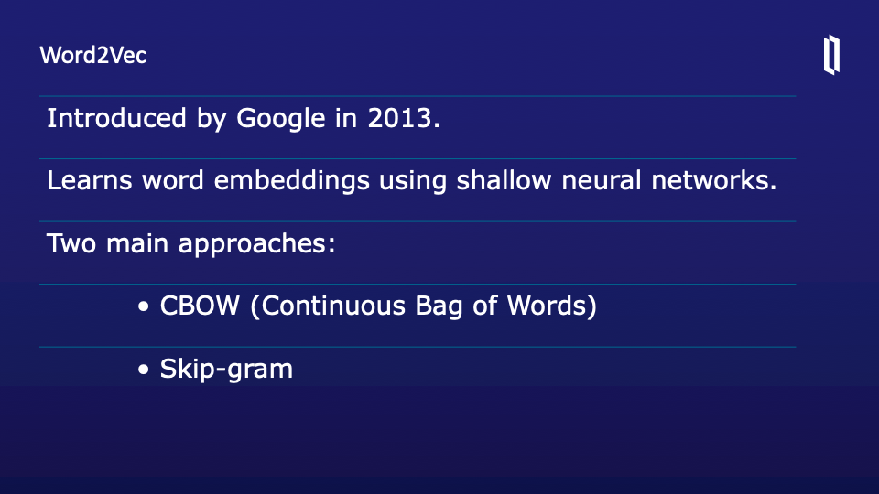

Word2Vec was a major breakthrough in the development of modern NLP, introduced by Google researchers in 2013. It allowed us to move beyond the limitations of one-hot encoding by representing words as continuous vectors in a way that captures semantic similarity. That is, words that appear in similar contexts—like “insulin” and “glucose”—end up near each other in the embedding space.

Word2Vec uses a shallow neural network architecture, which makes it computationally efficient and scalable to very large datasets. The model is trained in one of two ways: using either the CBOW method—Continuous Bag of Words—or the Skip-gram model.

CBOW tries to predict a word based on its surrounding context. So if we have the sentence “The patient has ___ levels of glucose,” CBOW learns to predict “high” or “elevated.” On the other hand, the Skip-gram model does the reverse: given a target word, it tries to predict the context words. For example, starting with the word “diabetes,” it would try to predict surrounding words like “blood,” “sugar,” or “chronic.”

These embeddings are foundational for many downstream tasks in healthcare AI, including concept similarity, search, and clinical classification. They were also a critical stepping stone toward more advanced models like transformers and LLMs.
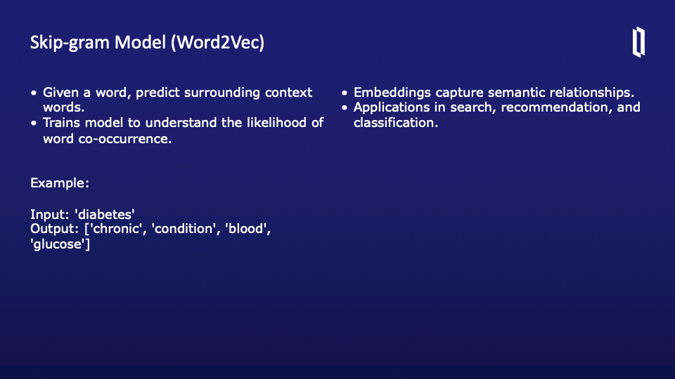

One advantage of skip-gram is that it works well with smaller datasets and captures meaning even for rare words. It’s especially useful in healthcare, where certain terms may not appear frequently but are contextually important. The embeddings generated capture nuanced medical relationships, making them valuable for tasks like search, recommendation engines, and clinical text classification. These vector representations form the base layer of many modern language models used in clinical NLP and FHIR applications.
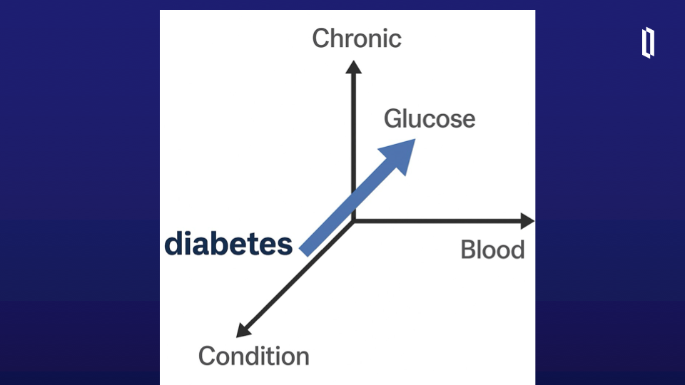

This diagram visualizes how word embeddings work in practice. The word “diabetes” is represented as a vector in a multi-dimensional space. Nearby vectors—like “chronic,” “condition,” “blood,” and “glucose”—are semantically related terms, often found in similar contexts. The direction and proximity of these vectors illustrate how the model captures meaning. Words with similar medical relevance or usage end up close together. This is what allows downstream models to generalize—to recognize that “glucose” is relevant to “diabetes,” even if that exact phrase pairing wasn’t in the training data. It’s a powerful foundation for medical NLP applications.

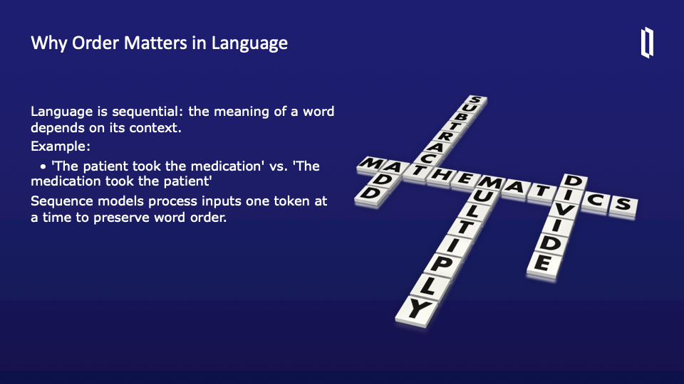
In natural language, meaning is not just in the words themselves—it’s in their order. The sequence of words determines how we understand the intent and structure of a sentence. Consider the difference between “The patient took the medication” and “The medication took the patient.” These are the same words but convey completely different meanings. That’s why sequence modeling became so crucial in NLP.

Early models ignored order—they treated text like a bag of words. But sequence-aware models helped the field evolve significantly. These models take input one token at a time and maintain context across the sentence or paragraph. This ability to track dependencies and evolving meaning across time is especially important in healthcare. Clinical language is complex and often non-linear. Models must capture temporal dependencies, such as a medication given before an adverse event or a symptom that emerged after treatment. By modeling sequence, we make it possible for algorithms to understand not just what was said, but how each piece of data relates to what came before and after it
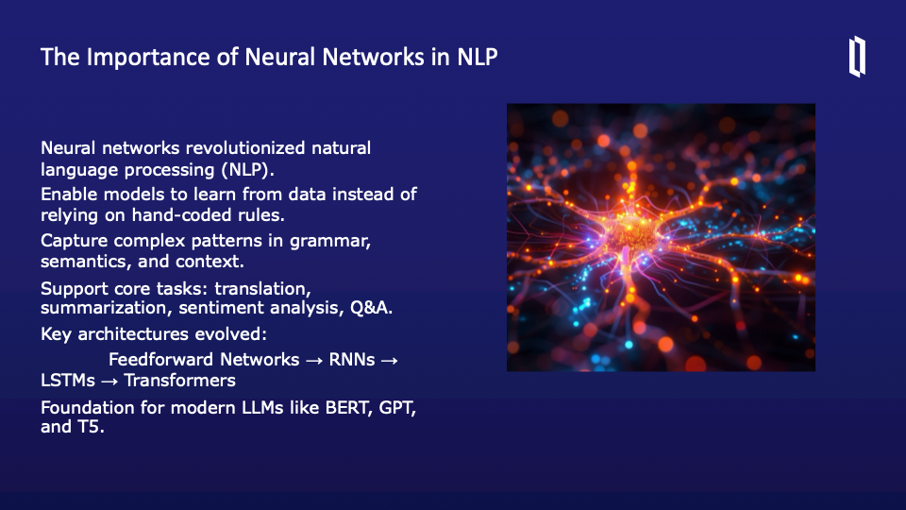
A turning point in our journey through NLP was the emergence of neural networks, which fundamentally transformed how we process language with machines. Before neural networks, most NLP systems relied on rule-based methods—carefully written scripts that looked for keywords, specific patterns, or hand-built grammars. These systems worked for narrow tasks but were brittle and hard to scale.

Neural networks allowed models to learn from data directly. Instead of manually defining what “hypertension” looks like in text, the model learns to recognize it—and its clinical variations—through exposure to examples. This is especially critical in healthcare, where language is complex, domain-specific, and often informal.

What neural networks really excel at is capturing rich patterns in grammar, semantics, and context. They allow models to go beyond surface-level features and learn the structure of language. As a result, they now support nearly every major NLP task: machine translation, document summarization, sentiment analysis, and open-ended Q&A.

The progression of neural network architectures is also important. We began with feedforward networks, which had no memory. Then came RNNs, which introduced sequential memory, and LSTMs, which extended that memory span. Finally, transformers revolutionized the field by enabling models to process entire sequences at once with self-attention.

These developments form the foundation of modern LLMs—like GPT, BERT, and T5—that power today’s most advanced AI applications. Without neural networks, we wouldn’t have the models capable of interpreting complex clinical language or generating fluent summaries of FHIR data.
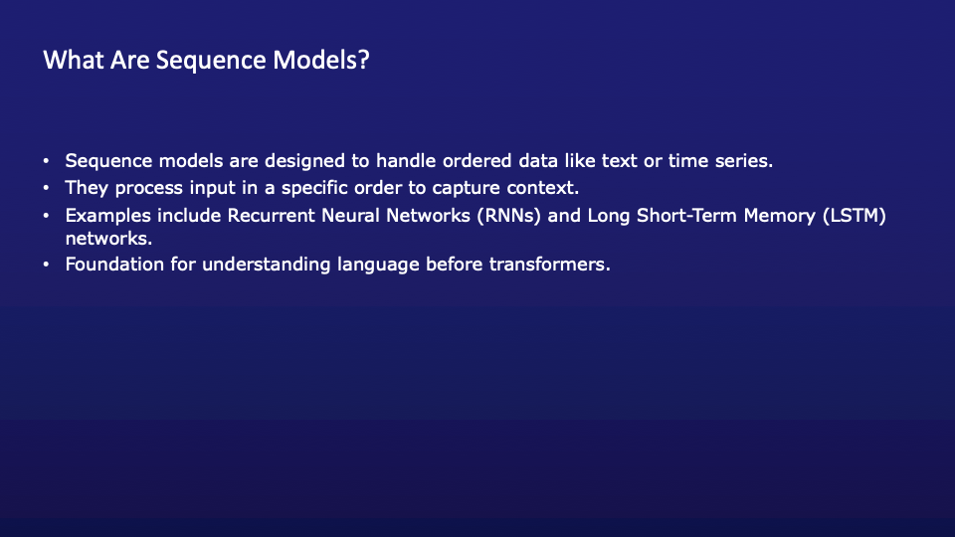
Sequence models are a crucial class of neural networks designed specifically for ordered data, such as text, speech, or time-series signals—anything where the position of each element matters. In language processing, the meaning of a sentence depends not just on the words it contains, but the order they appear in. For example, “The patient received the diagnosis” carries a very different implication than “The diagnosis received the patient.”

These models process input one step at a time, allowing them to track how meaning evolves across a sequence. The two most well-known types are Recurrent Neural Networks (RNNs) and Long Short-Term Memory (LSTM) networks. RNNs carry information forward at each step through a hidden state, while LSTMs improve upon this by deciding what to retain or forget using special gates. This makes LSTMs better at managing long-range dependencies in text.

Sequence models were a foundational leap in NLP before transformers took center stage. They enabled earlier systems to perform tasks like machine translation, sentiment analysis, and medical event detection. In the context of healthcare, they’re particularly valuable for interpreting longitudinal clinical data—tracking a patient's condition or treatment over time. They were the first models to truly grasp the temporal structure of language.

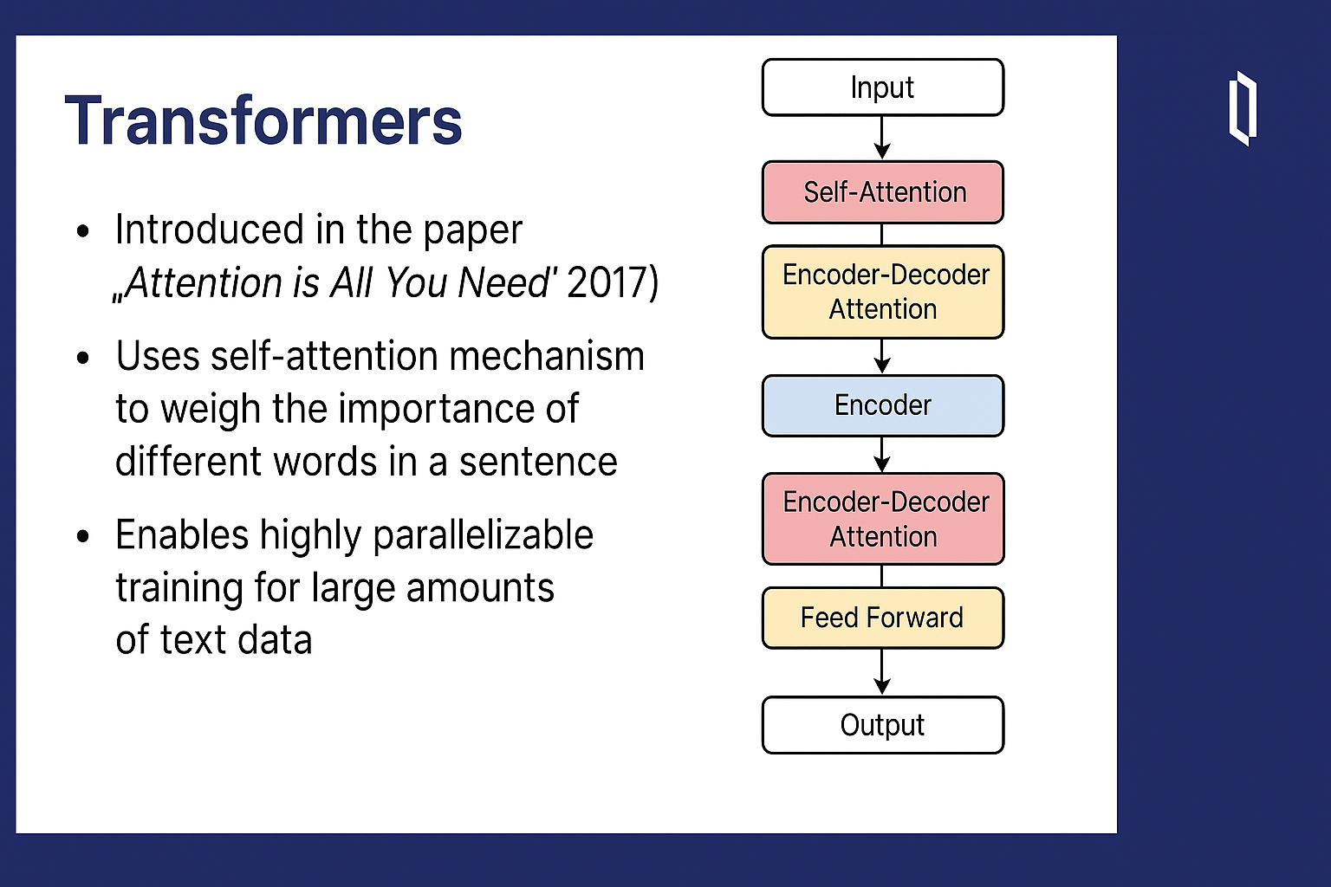
Transformers represent one of the most important advancements in the history of natural language processing. They were introduced in the landmark 2017 paper titled “Attention Is All You Need.” Unlike previous models like RNNs or LSTMs, transformers don’t process text strictly in sequence. Instead, they rely on a mechanism called self-attention, which allows the model to weigh the importance of every word in the input relative to every other word—regardless of position.

For example, in a clinical sentence like “The patient was given insulin because their blood glucose was high,” the model can learn to connect “insulin” with “blood glucose” even if several tokens separate them. This capacity to focus on relevant parts of the text—whether they come before, after, or are far apart—is what makes transformers so powerful.

The other major advantage is that transformers enable parallel processing. Unlike RNNs, which must process tokens one at a time, transformers can look at an entire sequence simultaneously. This greatly speeds up training and makes it feasible to train models on massive datasets—billions of tokens at once.

In the diagram on the right, you can see the core building blocks of a transformer model: self-attention layers, feed-forward neural networks, and encoder-decoder attention. These are stacked repeatedly to form deep architectures capable of sophisticated language understanding.

Transformers now serve as the backbone of today’s LLMs, including GPT, BERT, and T5. They are the engine behind everything from language generation to document summarization in clinical applications.
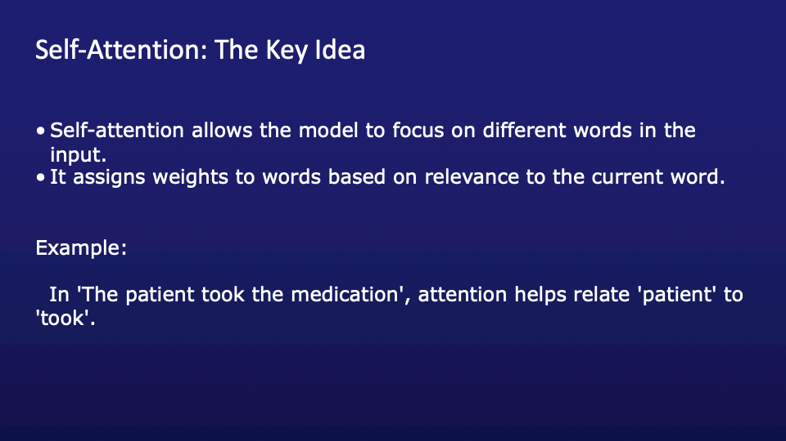
Self-attention is the heart of the transformer architecture—it’s what gives these models their power and flexibility. The basic idea is simple but incredibly effective: instead of processing text word by word in order, self-attention lets the model look at all words in the sequence at the same time and assign different levels of importance to each one.

Imagine you’re reading the sentence, “The patient took the medication.” If you want to understand what “took” refers to, you need to link it to “patient.” That’s exactly what self-attention does—it calculates how much attention the word “took” should give to “patient,” “medication,” and every other word in the sentence. These attention weights help the model make informed decisions about meaning and relationships.

What’s especially powerful is that this mechanism works regardless of distance. So in a long clinical note, a model can link symptoms in the first paragraph to diagnoses in the last, which traditional RNNs and LSTMs often struggled with.

Self-attention allows the model to dynamically adapt its focus as it processes different tokens. It’s context-aware, scalable, and highly effective. Without self-attention, we wouldn’t have the language understanding capabilities we see in today’s large language models like GPT and BERT.
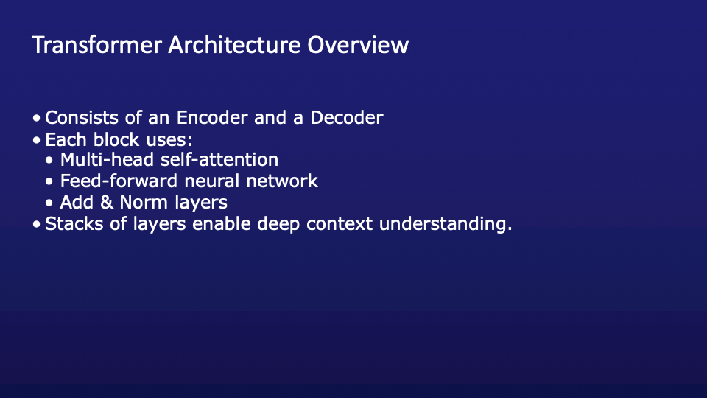

This slide provides a conceptual overview of the full transformer architecture, which consists of two main components: the encoder and the decoder. Together, these modules enable the model to deeply understand an input sequence and generate a coherent, context-aware output sequence. Let's break them down.

________________________________________

Encoder: Understanding the Input

The encoder processes the entire input sequence in parallel and produces contextual embeddings-vector representations that carry not only the meaning of each word but also how it relates to other words in the sequence.

Key steps in the encoder:

Input Embedding: Each input token (e.g., a word or subword) is first converted into a vector using a learned embedding table.

Positional Encoding: Since transformers don't have built-in sequence order (unlike RNNs), we add positional encodings to the embeddings to help the model learn word order.

Stack of Encoder Layers: The original transformer used 6 layers. Each layer includes:

Multi-head self-attention: Lets each token "look at" all others in the sequence to gather context.

Feed-forward network: A small neural network that processes each position independently.

Add & Norm layers: Residual connections and normalization stabilize learning and allow gradients to flow easily.

The encoder outputs a set of contextual vectors, one per token, which summarize the meaning of each word in context.

________________________________________

Decoder: Generating the Output

The decoder generates the output sequence one token at a time, using both the encoder outputs and the previously generated tokens for context.

Key steps in the decoder:

Output Embedding: Each token already generated is embedded, similar to the encoder.

Positional Encoding: Again, we preserve word order with position information.

Stack of Decoder Layers: Also usually 6 layers, each includes:

Masked multi-head self-attention: Prevents the decoder from peeking at future tokens during generation.

Multi-head cross-attention: Attends to encoder outputs, effectively linking the input to the output.

Feed-forward network

Add & Norm layers

At each time step, the decoder predicts the next token using a probability distribution over the vocabulary.

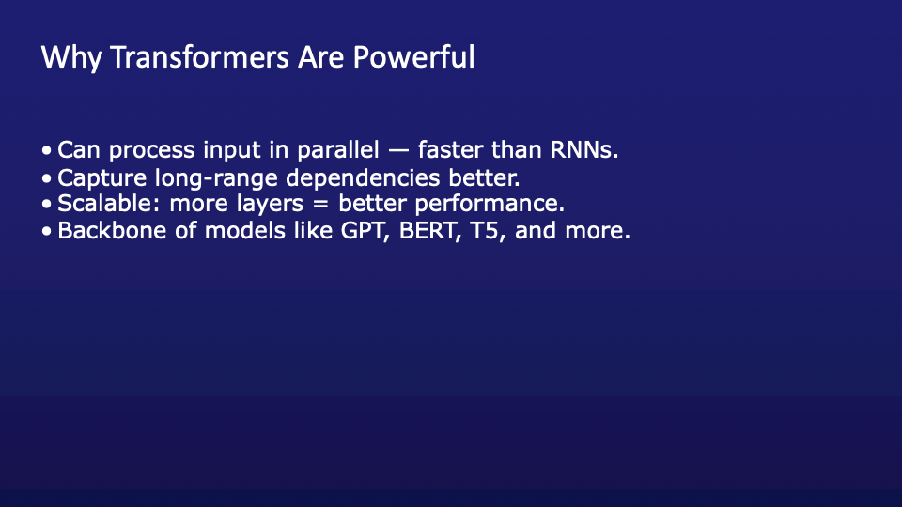

Transformers are powerful because they overcome many limitations of earlier sequence models like RNNs and LSTMs. The first major advantage is parallelization. Unlike RNNs, which process tokens one at a time, transformers can process an entire input sequence simultaneously. This makes training much faster and allows the model to scale to very large datasets—critical when working with internet-scale text or vast amounts of clinical notes.

Second, transformers are much better at capturing long-range dependencies. Thanks to self-attention, a token at the beginning of a sentence can directly access and weigh tokens from much later in the sequence. This is particularly useful in healthcare, where a symptom might be mentioned early in a note and only explained several paragraphs later.

Third, transformers are scalable by design. Adding more layers improves their capacity, enabling deeper contextual understanding. This means we can tailor model complexity to the task—lightweight for edge devices or massive for research.

Finally, transformers are the backbone of today’s most advanced models—including GPT, BERT, and T5. Each of these models uses the transformer architecture as its core engine for understanding and generating language. This flexibility and power make transformers the foundation for almost all modern NLP, including applications in FHIR data interpretation and clinical summarization.

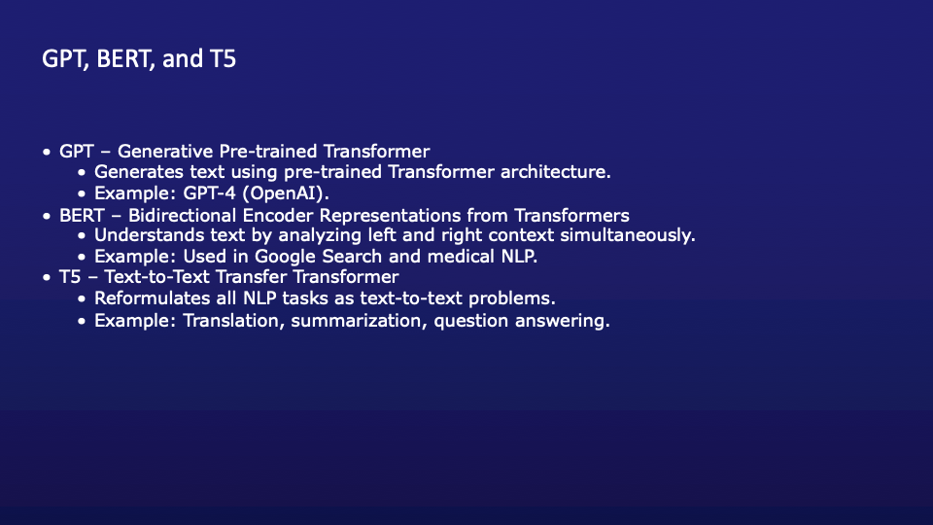

This slide highlights three of the most influential transformer-based models in natural language processing—GPT, BERT, and T5—each with a unique architectural design and purpose.

Let’s start with GPT, which stands for Generative Pre-trained Transformer. GPT models are designed to generate text. They’re trained to predict the next word in a sentence, making them excellent at producing fluent, human-like language. GPT-4 from OpenAI is a prime example, powering applications in chatbots, summarization, and more. Its architecture is decoder-only and autoregressive—meaning it predicts tokens one at a time, always using past context.

Next is BERT—Bidirectional Encoder Representations from Transformers. BERT is focused on understanding language rather than generating it. It reads text in both directions simultaneously, giving it a more holistic view of meaning. This makes BERT ideal for tasks like classification, named entity recognition, and question answering. It’s widely used in tools like Google Search and for biomedical NLP tasks.

Finally, T5, or Text-to-Text Transfer Transformer, reformulates all NLP tasks as a text-in, text-out problem. Whether it's summarization, translation, or answering questions, everything is cast as a text transformation task. This unified format simplifies training and increases model flexibility.

Together, these models demonstrate the versatility and power of transformer-based architectures.

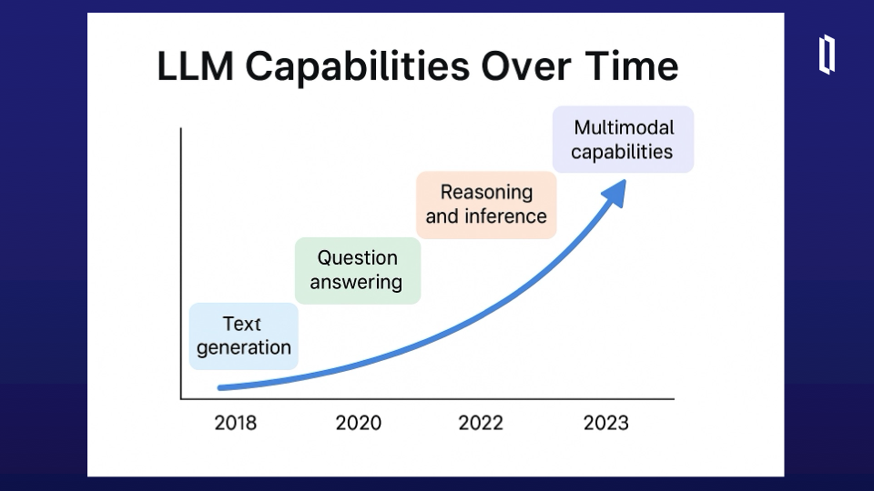

This slide illustrates how large language models (LLMs) have evolved in terms of capability over time—from early text generation to today’s cutting-edge multimodal applications. Starting around 2018, models like GPT-2 demonstrated strong text generation capabilities. They could autocomplete prompts or generate summaries, but their understanding of deeper context was still limited.

By 2020, models such as GPT-3 and BERT had improved to handle question answering more effectively, especially in structured settings like healthcare or legal domains. They could extract relevant information from long texts and provide concise, context-aware responses.

Around 2022, LLMs began to show real promise in reasoning and inference. With prompt engineering and chain-of-thought techniques, these models could follow logical steps and offer multi-part explanations—critical for clinical decision support or complex patient queries.

And most recently, we’ve entered the age of multimodal capabilities. Models like GPT-4 and others now accept text, images, and even audio as input. This opens the door for applications like radiology report generation from scans, visual symptom checkers, and mixed-media health assistants.

This trajectory reflects both the increased scale of training and the architectural innovations that make modern LLMs adaptable, general-purpose reasoning tools.

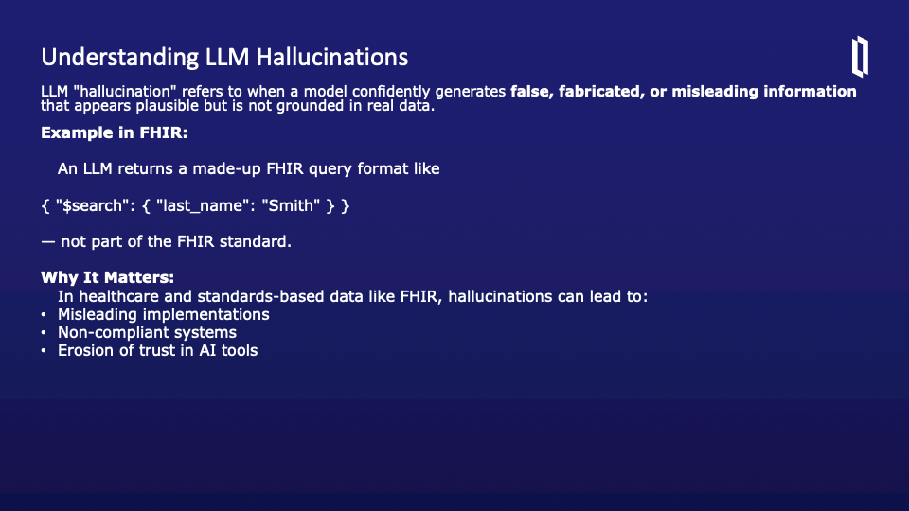

Although I and many others are very impressed by the power of LLMs we cannot forget about one of their weaknesses -- hallucinations. A hallucination occurs when an AI model generates information that sounds correct but is in fact false or unsupported. This is especially dangerous in domains like healthcare, where accuracy and adherence to standards like FHIR are critical.

The example here illustrates how a model can fabricate a FHIR query format that appears valid but doesn't conform to the FHIR specification. This kind of hallucination isn’t just a harmless mistake — it can lead developers down the wrong path, resulting in misleading implementations, non-compliant systems, or even clinical errors if unchecked.

It's important to understand that these errors aren't due to malice or bugs — they come from how LLMs are trained: to predict what looks most probable, not what’s necessarily true. This is why careful validation, documentation grounding, and expert oversight are key when using LLMs in healthcare contexts.

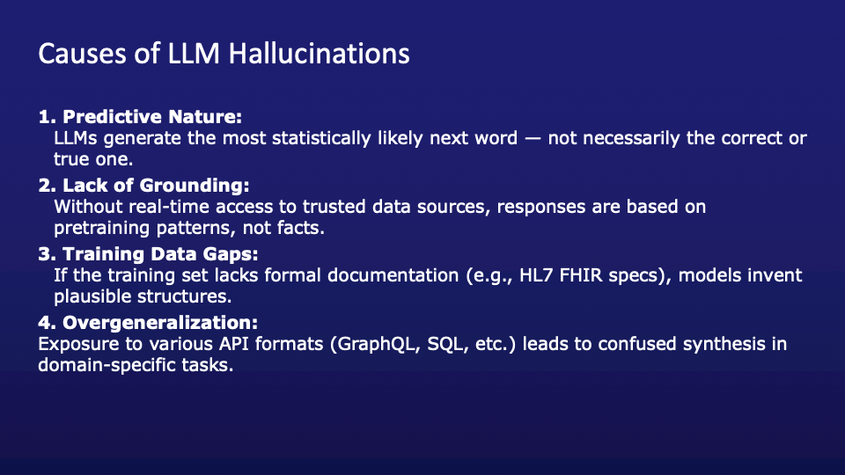

There are several causes for why large language models hallucinate —producing entirely fabricated content that may look correct. The key to understanding is how LLMs work. These models aren’t knowledge engines; they’re sophisticated pattern matchers trained to predict the next word in a sequence based on statistical patterns in their training data.

The first major cause of hallucinations is this predictive nature. The model doesn’t know if what it’s saying is true — it just knows it sounds plausible. That’s especially problematic in domains with precise standards, like FHIR, where there’s only one correct way to structure a query or represent clinical data.

Another key issue is the lack of grounding. Without access to real-time, authoritative data sources — like the HL7 FHIR documentation — the model relies on its memory, which may be outdated or incomplete.

Training data gaps are also common. If a model wasn’t trained on high-quality FHIR examples, it may synthesize APIs from other formats it has seen, such as GraphQL, SQL, or internal schemas.

Finally, we have overgeneralization. The model blends structures and conventions across contexts, leading to confident but invalid outputs.

Understanding these causes helps us design better safeguards and workflows when using LLMs in sensitive fields like healthcare, where accuracy and compliance are non-negotiable.

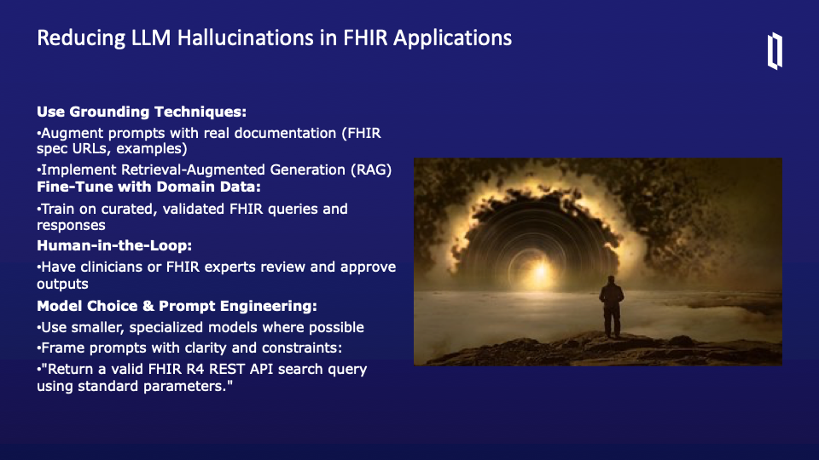

Here are some strategies to reduce hallucinations.

The first and most effective strategy is grounding. This means providing the LLM with access to real, authoritative sources during inference. You can embed URLs to the FHIR spec, examples from HL7, or even integrate Retrieval-Augmented Generation, or RAG, which dynamically pulls in relevant documents as context.

Next is fine-tuning with domain-specific data. If you're building a FHIR-specific assistant or code generator, train the model on actual FHIR queries and valid resource representations. That way, it learns patterns that align with the real spec — not general approximations.

Human-in-the-loop systems are also crucial. Whether it’s a developer, a FHIR SME, or a clinician, human review ensures that outputs meet both functional and regulatory standards before being trusted in production.

Lastly, don’t underestimate the power of model choice and prompt engineering. Simpler, smaller models may hallucinate less when fine-tuned well. And clear, specific prompts — like “return a valid FHIR R4 REST API search query” — can dramatically improve reliability.

Together, these strategies form a toolkit for safer, more trustworthy LLM applications in healthcare.



Just display for a few seconds.

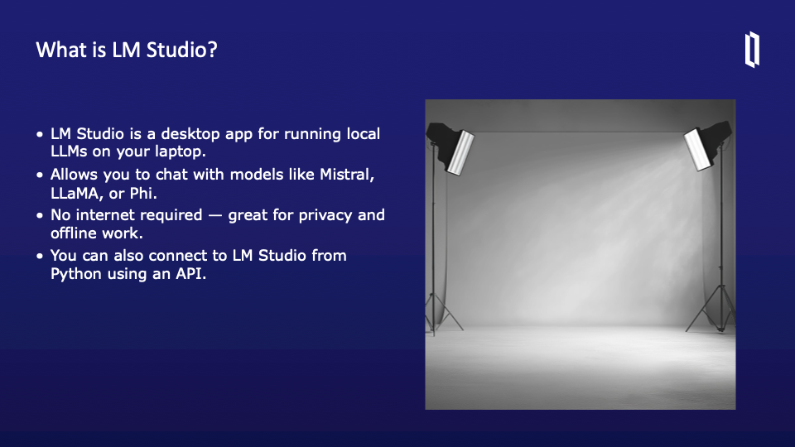

LM Studio is a powerful desktop application designed to run large language models locally on your machine. This means you can interact with AI models like Mistral, LLaMA, or Phi directly from your laptop without relying on cloud services. It’s particularly valuable for those who prioritize data privacy, as it doesn’t require an internet connection once the models are downloaded — making it ideal for secure or offline environments.

Another great feature is its flexibility. Beyond the desktop interface, LM Studio exposes an API, so you can programmatically interact with the models from your Python code. This opens up opportunities for integrating local AI into your workflows, building applications, or conducting experiments without external dependencies.

In short, LM Studio brings the power of LLMs directly to your personal device, giving you control, privacy, and programmability — all without sending your data to a third party.

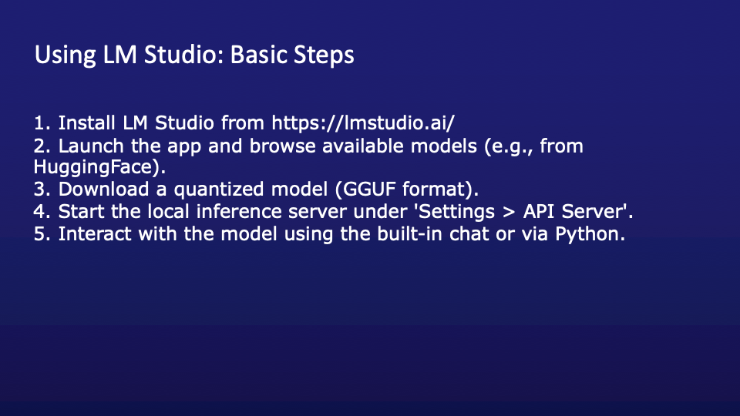

First, you’ll need to download and install the app from the official website: https://lmstudio.ai. It’s available for major desktop platforms and installation is straightforward.

Once installed, launch the application. LM Studio includes a model browser that lets you search and download models from sources like Hugging Face. You’ll want to look for models that are already in GGUF format — that’s a quantized format optimized for local inference.

After selecting a model, download it within the app. The quantized version helps reduce memory usage while maintaining good performance — especially useful if you're working on a laptop with limited resources.

Next, go into the application’s settings and start the local inference server. This is found under Settings > API Server. Turning this on allows you to send requests to the model from external tools, such as Python scripts or applications.

Finally, you can now interact with the model. LM Studio has a built-in chat interface for testing, or you can connect to it programmatically via an API. This makes it very easy to build or test AI-enabled tools locally, without depending on any cloud service.

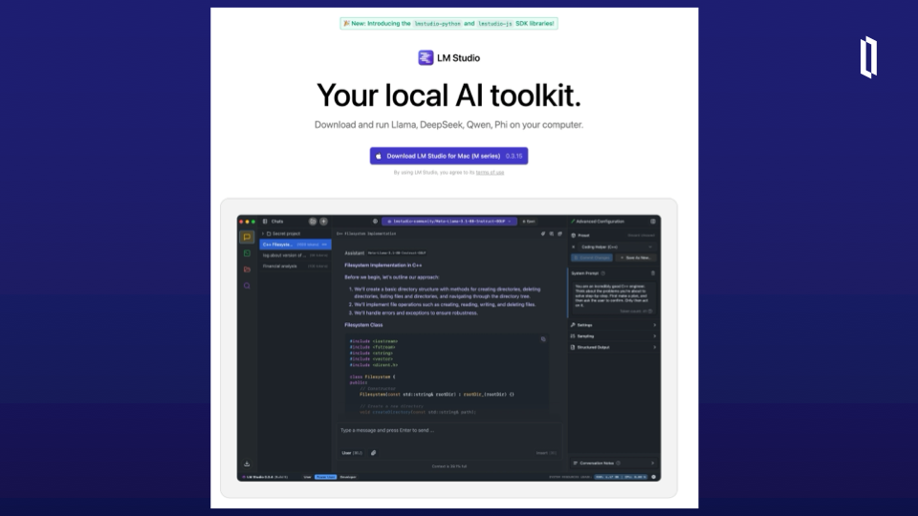

Just comment how we will download and get this running as part of the demo.

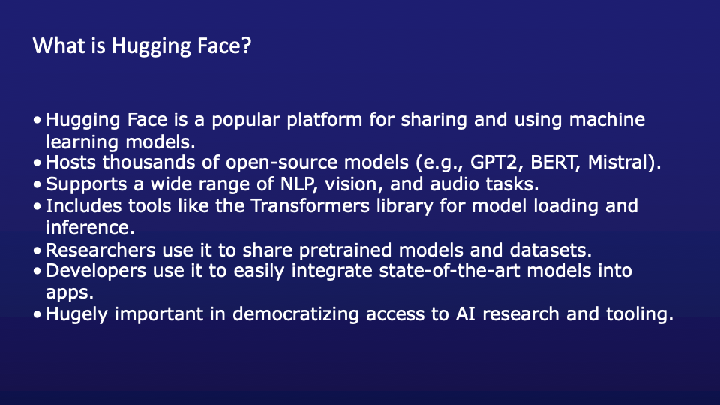

Hugging Face is a widely used platform in the machine learning community that makes it easy to share, discover, and use models and datasets. At its core, it's like GitHub for AI models. It hosts thousands of open-source models, including well-known ones like GPT2, BERT, and newer models like Mistral and Phi.

It supports a wide variety of tasks — from natural language processing to computer vision and audio generation — making it useful across many domains. One of Hugging Face’s major strengths is the ecosystem it has built around model usage, especially with tools like the Transformers library. This library allows developers to easily load pretrained models with just a few lines of code and start making inferences.

Researchers benefit from Hugging Face by using it as a place to publish their models and datasets. Developers and startups use it to pull in powerful models and build smart applications quickly. Hugging Face has played a huge role in democratizing access to AI — bringing cutting-edge tools to more people regardless of their resources.

Now, tying this back to LM Studio: LM Studio can download models directly from Hugging Face. When you're browsing for a model in LM Studio, it's essentially tapping into the Hugging Face hub. As long as the model is available in GGUF format, LM Studio can run it locally. This combination — using Hugging Face to access models and LM Studio to run them offline — is powerful for building private, local AI workflows.

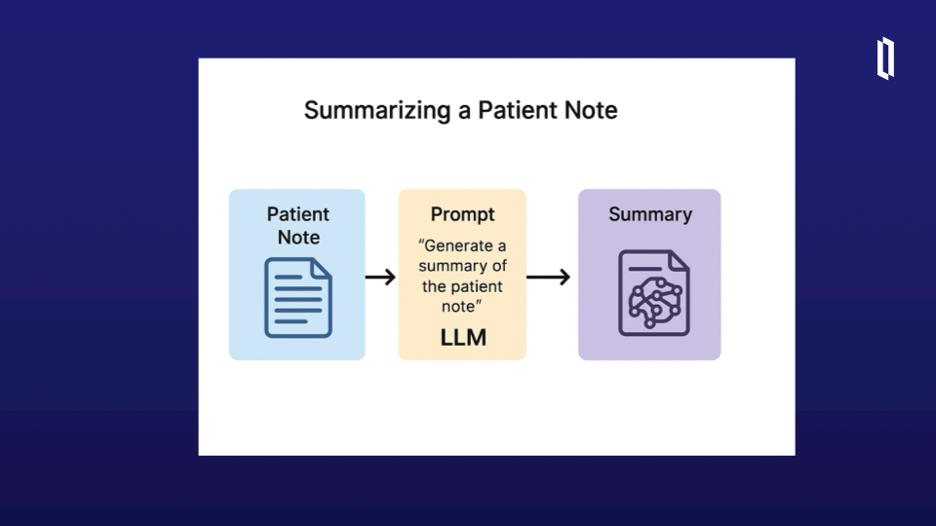

In our variation of the summarization use case, the source data is structured in FHIR format—specifically, we’re working with FHIR Patient, Observation, Condition or other resources that contain or reference the patient’s clinical notes.

The process begins by extracting the narrative or text content from the relevant FHIR resources. This could be done using a FHIR API or library such as fhir.resources in Python. Once we have the relevant text from the FHIR bundle, we pass it to an LLM, either locally using LM Studio or through a secure API.

The prompt might say, “Summarize the clinical content of this FHIR patient note,” and the input text would include the structured content extracted from the FHIR resource. The model then generates a summary, which can be returned to the user or even written back into the FHIR ecosystem, potentially as a new DocumentReference or Annotation.

This approach is especially useful in environments where FHIR is already in use—such as EHRs, research platforms, or integration engines—because it allows for automation and summarization while staying within the FHIR data model. It’s a great example of combining interoperability standards with AI-driven insight.

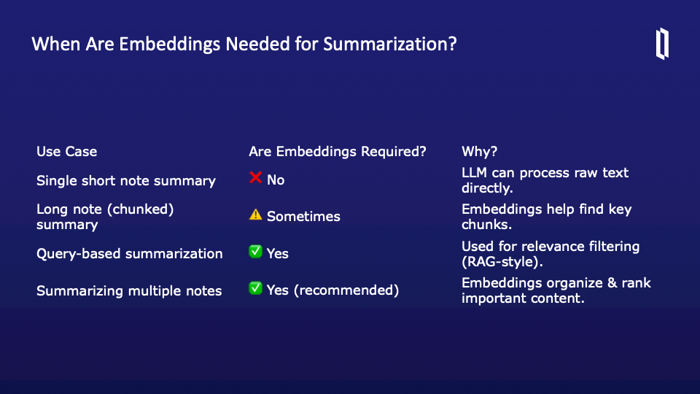

This slide helps clarify when embeddings are required in different summarization use cases. As we work with large language models, it's important to understand that embeddings—vector representations of text—are not always necessary, but in some scenarios, they dramatically improve performance.

For a single short note, no embeddings are needed. The LLM can handle the entire note in a single pass. This is ideal for fast, lightweight summarization tasks where the context fits within the model’s input limit.

However, with a long note, things change. If the note is too large to fit in one prompt, we may need to chunk it and use embeddings to identify and prioritize the most relevant sections. In these cases, embeddings can help the model focus on the important content.

For query-based summarization, such as answering “what are the key diagnoses?” across one or more notes, embeddings are crucial. This is similar to RAG—Retrieval-Augmented Generation—where we use embeddings to filter for relevance before sending context to the model.

Finally, when summarizing multiple notes, embeddings are recommended. They help organize, rank, and condense the most important content across disparate documents.

So overall, embeddings add value especially when you're working with large or multiple documents or when precision and relevance filtering are critical.

